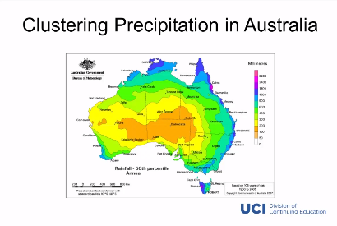**K Means Clustering for Clustering Precipitation**

Clustering by amount of millimeters, rather than by map area.

K- means clustering algorithm applied to students’  
academic performance